

KING’S OWN INSTITUTE*
Success in Higher Education

GROUP ASSIGNMENT COVERSHEET

Subject Code & Name: ICT203 - Human Computer Interaction
Lecturer’s/Tutor’s name: Najamul Khan
Assignment Title: EduConnect – Project Plan

Declaration
(This declaration must be completed by all students in the group, or the assignment will not be marked)

We, the undersigned, certify the following:
- We have read and understood the Student Academic Misconduct Policy
- This assignment is our own work based on our personal study and research.
- We have acknowledged all material and sources used in the preparation of this assignment including any material generated in the course of our employment.
- The assignment has not previously been submitted for assessment in this or any other unit.
- We have not copied in part or in whole or otherwise plagiarised the work of other students.
- We have read and understand the criteria used for assessment.
- The assignment is within the word and page limits specified in the unit outline.
- The use of any material in this assignment does not infringe the intellectual property / copyright of a third party.
- We understand that this assignment may undergo electronic detection for plagiarism, and an anonymous copy of the assignment may be retained on the database and used to make comparisons with other assignments in future.
- By completing this coversheet in full and submitting this assignment electronically, we are bound by the conditions of the KOI's Student Academic Misconduct Policy and the declaration on this coversheet.

 | Family Name | Given Name(s) | Student ID | Tutorial Code | Contribution Percentage | Signature
Student 1 | Edoardo | Edoardo | 20035490 | LAT20126 | 20% | Edoardo
Student 2
Student 3
Student 4
Student 5
Word count =

Assignment Receipt
Subject Code & Name: Lecturer’s/Tutor’s Name: Assignment Title:

 | Family Name | Given Name(s) | Student ID | Tutorial/ Code | Signature
Student 1
Student 2
Student 3
Student 4
Student 5

Table of Contents

Contents
Declaration 1
Assignment Receipt 1
1. Title and Description of the Website 3
1.1 Website Title 3
1.2 Website Description 3
Design Plan (Preliminary Sketches) 4
1.1 Site Map 4
1.2 Page Description with Wireframe Diagrams 4
1.2.1 Homepage 5
2.2.2 About Page + Contact Page 5
2.2.3 Resource Page 6
2.2.4 Collaboration Page 7
2.2.5 Login Page 9
2. Member Roles and Responsibilities 10
3. Project Plan 11
4.1 Work Breakdown Structure (WBS) 11
4.2 Gantt Chart 11
4.3 Resource List 12
4.4 Risk Management Plan 13

ICT203 – PROJECT PLAN

Title and Description of the Website

1.1 Website Title
EduConnect – A Student Resource & Collaboration Website

1.2 Website Description
EduConnect is a web-based platform designed specifically for university students to access curated academic resources, collaborate on group projects, and connect with peers in a structured and user-friendly environment. The platform addresses a common student pain point: the scattered nature of study materials, group communication tools, and academic support across multiple unconnected systems.
The website will consist of the following core pages:
- Home Page – Overview of the platform with featured resources and announcements.
- Resource Library – Categorized repository of lecture notes, past papers, and study guides.
- Collaboration Hub – A space for students to form study groups and share project files.
- Events & Timetable – Calendar view of upcoming assessments and campus events.
- Contact & Support – A form and FAQ page for student support queries.
The prototype will be developed using HTML and CSS only, as stipulated in the assessment guidelines, and will demonstrate responsive, accessible, and visually consistent interface design principles.

Design Plan (Preliminary Sketches)
The EduConnect website will feature a user-friendly and responsive design to easily navigate students to each different sections and find the correct information. The final design will follow Ben Shneiderman’s eight golden rules of UI design to ensure that the design meets the criteria of an effective website (Shneiderman et al., 2018).

Site Map
A site map will highlight important information such as structure, design and relationship across each pages.

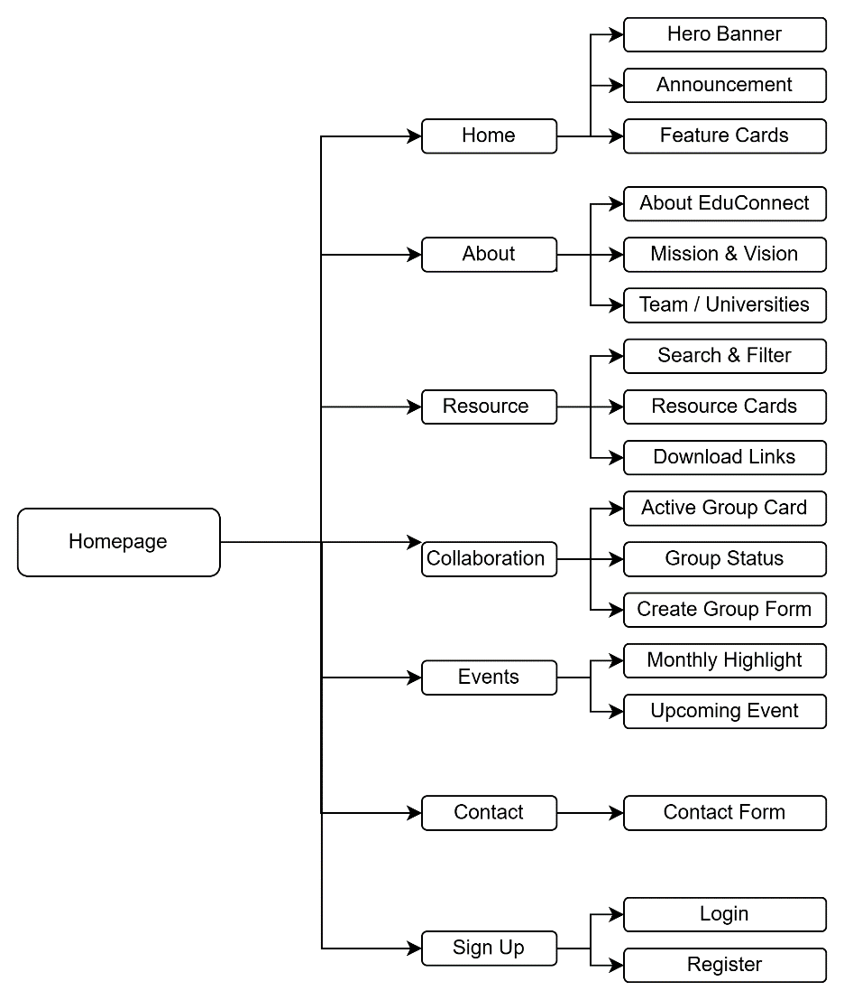

Page Description with Wireframe Diagrams
Wireframes are black and white sketches that mainly highlighting site features, layout and initial design of the website at the structural/prototype level (Becker, 2020).

Homepage
The website homepage has a layout that provide good short presentation of what the company does with some of resources that being shared as an example with announcement update that visible to all user as a proof of legitimate company. This is the landing page that user will see the first before all other pages.
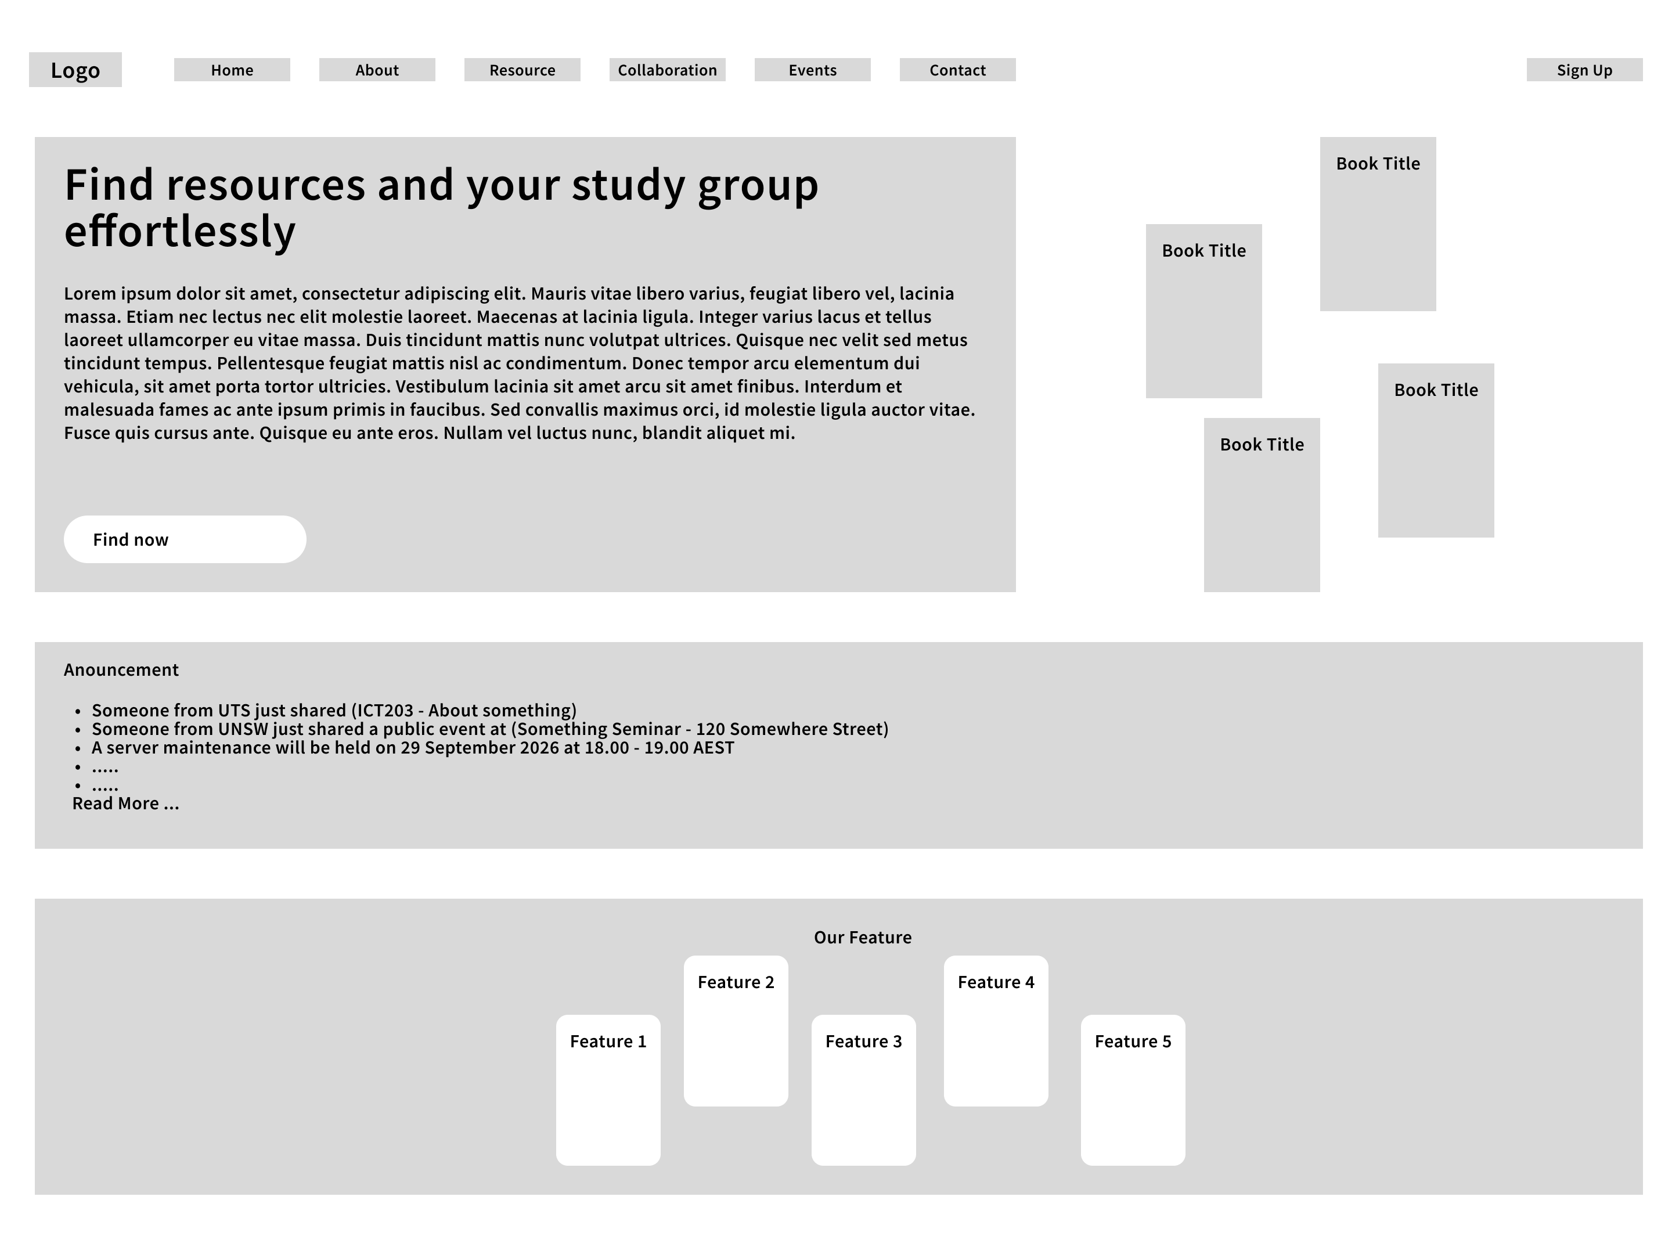

2.2.2 About Page + Contact Page
About page follows the principle of consistency and standards by maintaining the same navigation and layout as all other pages did (Shneiderman et al., 2018). It’s showing EduConnect Purpose, vision & mission and Our Partner, followed by Contact at the bottom

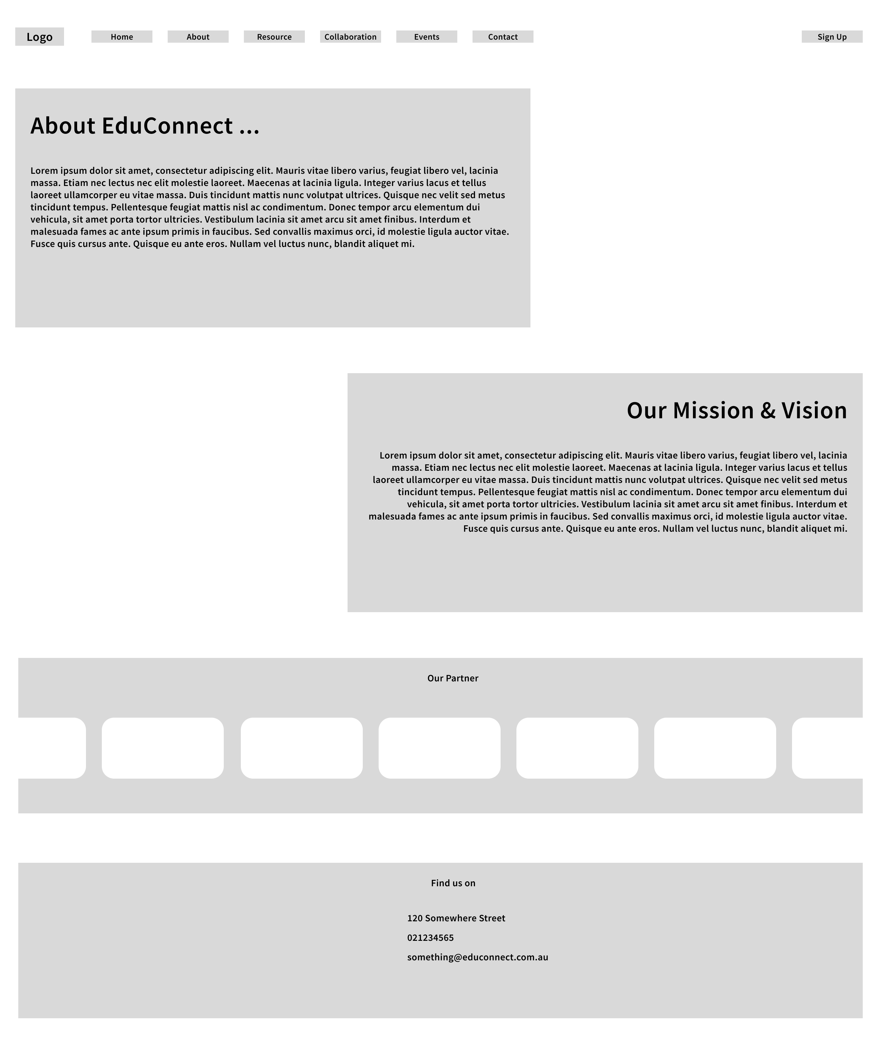

2.2.3 Resource Page
Resource Page is the main functional page where all students from every school can see shared resources in this page, as long as uploading it by Drag and Drop with pop-up menu appearing after dragging to the page with login

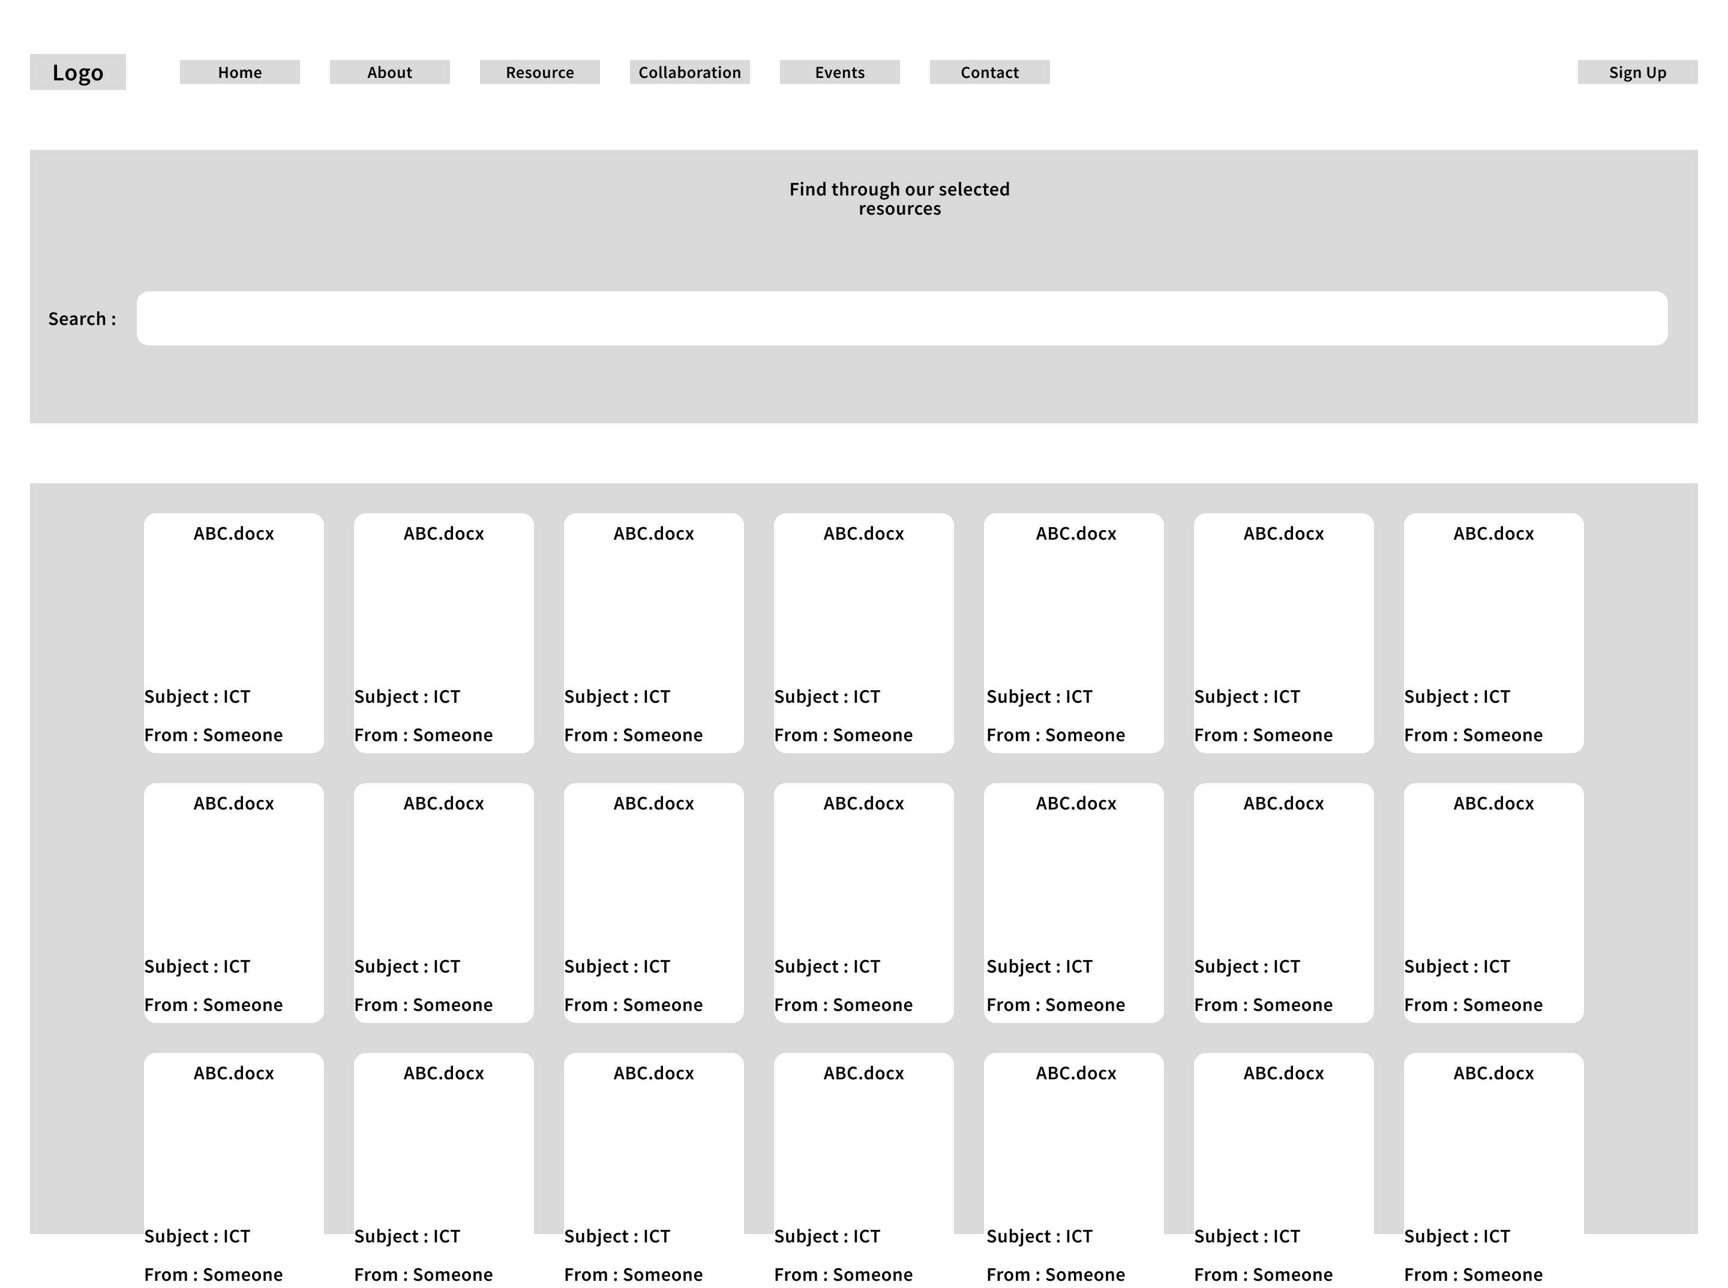

2.2.4 Collaboration Page
Collaboration Page is where all students can collaborate to create a group study with location and date details and active unactive status to determine the session status.

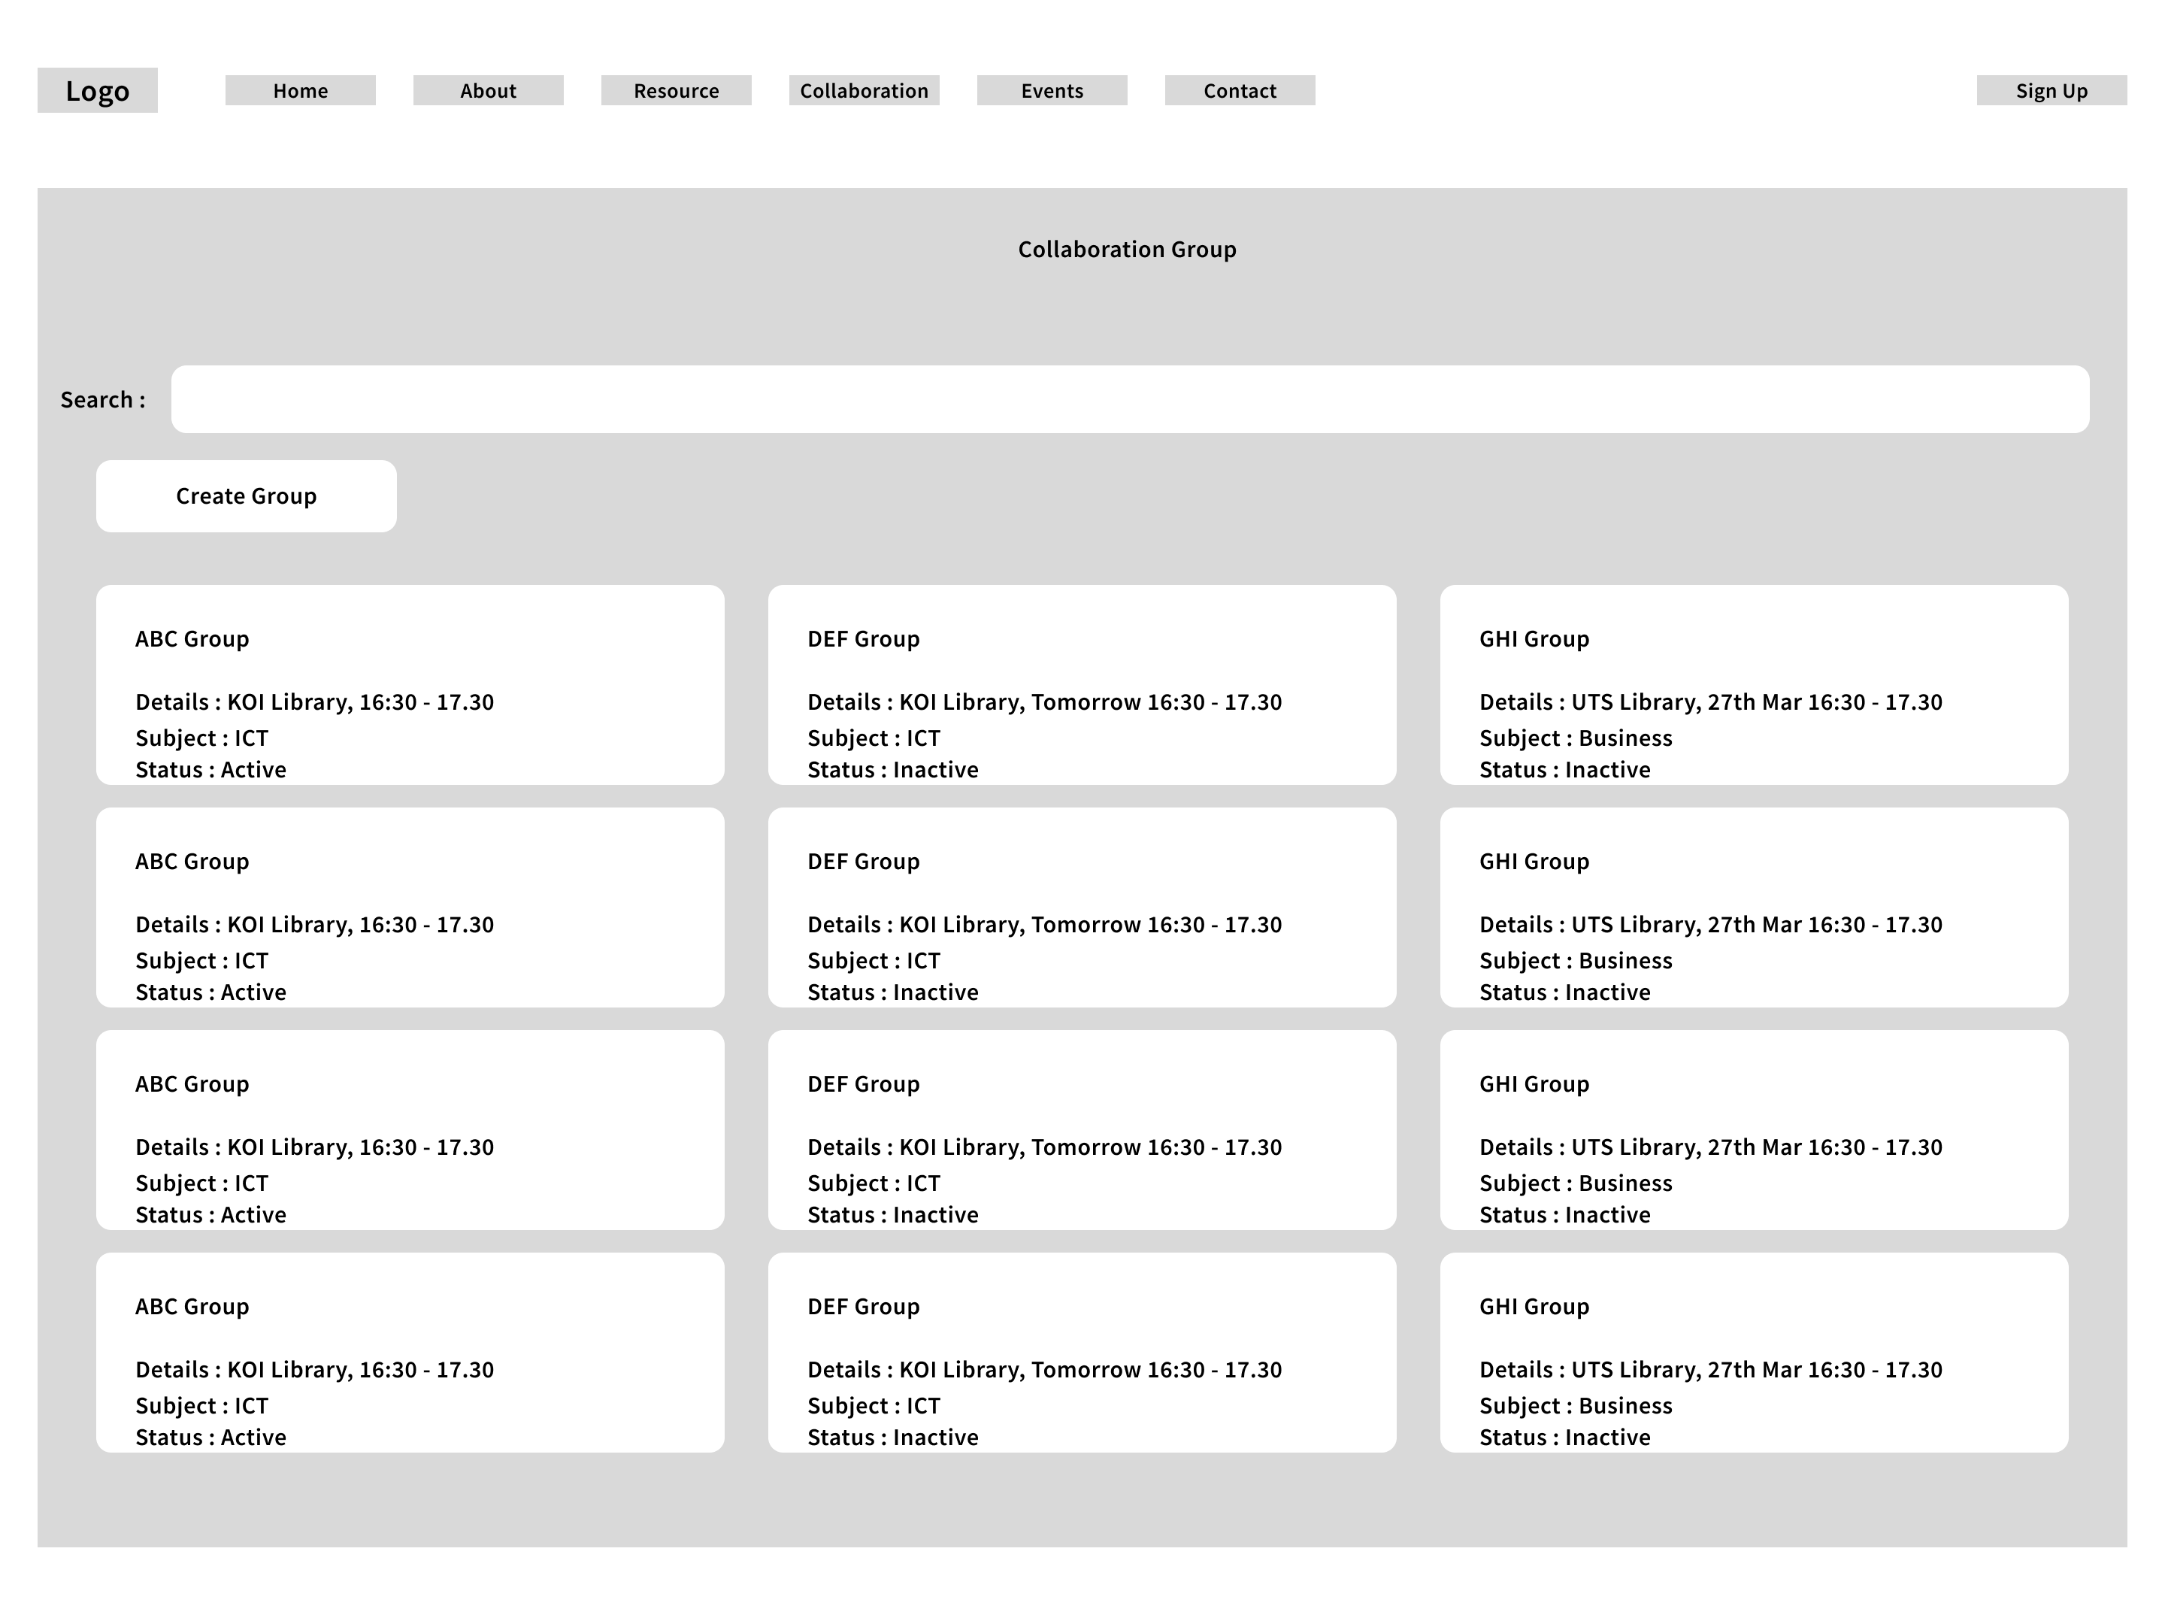

2.2.5 Login Page
Login page follow the standards that using the principle of error prevention by using clearly label input fields followed by error management if password are empty or is not authenticated.

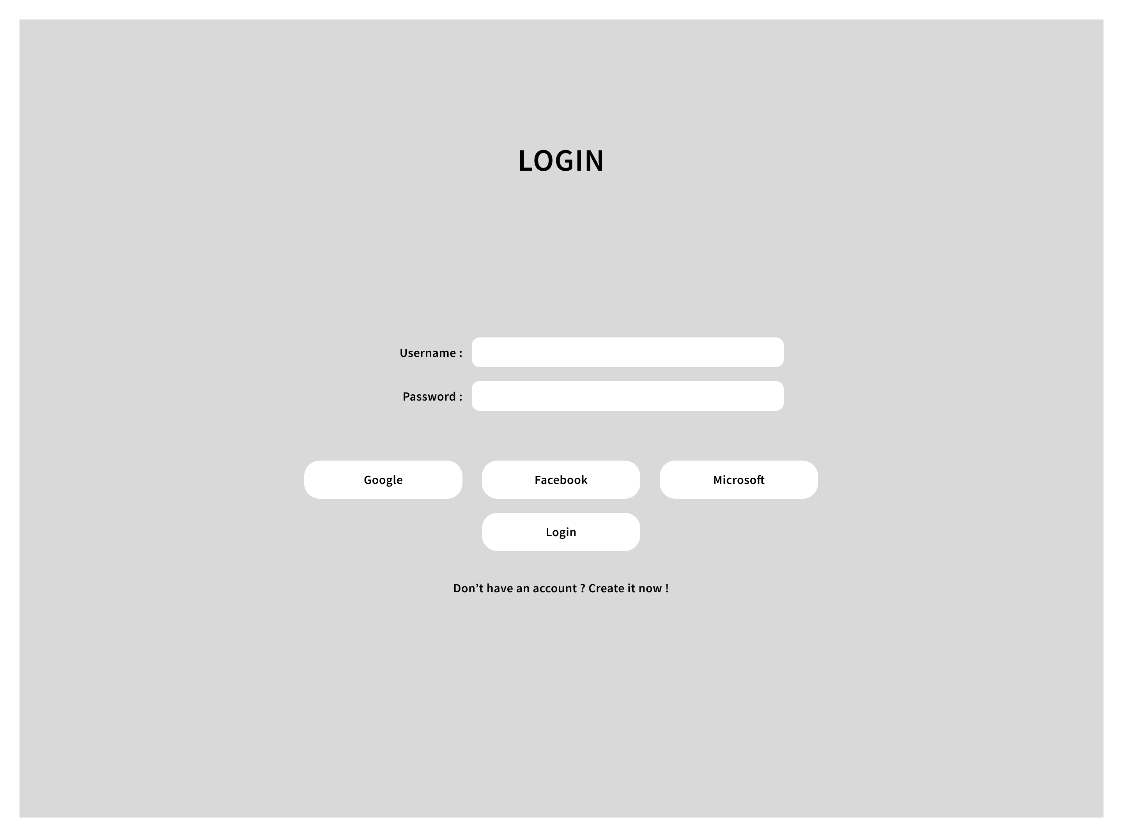

Member Roles and Responsibilities
Our group consists of four members. Roles have been assigned based on individual strengths and course competencies to ensure equitable workload distribution.
Member | Role | Key Responsibilities | Deliverables
Member 1 [Name] | Project Manager & Lead Developer | Coordinate meetings, manage timeline, develop Home and Navigation pages | index.html, nav.css, project schedule updates
Member 2 [Name] | UI/UX Designer | Create wireframes, define style guide, design Resource Library page | Wireframe sketches, style-guide.css, resources.html
Member 3 [Name] | Frontend Developer | Build Collaboration Hub and Events pages, implement responsive layout | collaboration.html, events.html, responsive.css
Member 4 [Name] | Content & Report Writer | Write report sections, Contact page HTML, compile references, coordinate testing | contact.html, group report draft, references list

All members are jointly responsible for attending weekly group meetings (scheduled every Tuesday, 5:00–6:00 PM), reviewing each other's work, and contributing to the final presentation.

Project Plan

4.1 Work Breakdown Structure (WBS)
WBS ID | Task | Description | Owner
1.0 | Project Initiation | Define scope, form team, assign roles | All members
1.1 | Project Plan Document | Write and submit Week 4 project plan | Member 1 & 4
2.0 | Design Phase | Wireframes, colour/font decisions, page layouts | Member 2
2.1 | Style Guide | Finalise CSS variables and shared stylesheet | Member 2
3.0 | Development Phase | Build all HTML/CSS pages per design | Members 1, 2, 3
3.1 | Home + Nav | index.html, navbar, footer, hero section | Member 1
3.2 | Resource Library | resources.html with filter layout | Member 2
3.3 | Collaboration & Events | collaboration.html, events.html | Member 3
3.4 | Contact & Support | contact.html with form and FAQ | Member 4
4.0 | Testing Phase | Browser testing, peer review, bug fixes | All members
5.0 | Report Writing | Draft and finalise group report (2,500 words) | Members 1, 4
6.0 | Presentation Prep | Prepare 15-minute presentation and demo | All members

4.2 Gantt Chart
The table below represents the project timeline across Weeks 1–12 of the semester. Shaded cells indicate active work periods.

Task | Owner | W1 | W2 | W3 | W4 | W5 | W6 | W7 | W8 | W9 | W10 |  | W11 | W12
Deliverables → W4 / W10 / W11-12 |  | Project Plan due |  |  |  | Development & Testing |  |  |  |  |  | Presentation
1. Project Initiation | All members
2. Project Plan | M1 + M4 |  |  |  | DL W4
3. Wireframes & Design | M2
4. Style Guide (CSS) | M2
5. Home + Navigation | M1
6. Resource Library | M2
7. Collaboration & Events | M3
8. Contact & Support | M4
9. Cross-browser Testing | All members
10. Peer Code Review | M1 + M3
11. Report Writing | M1 + M4 |  |  |  |  |  |  |  |  |  | DL W10
12. Presentation Prep | All members |  |  |  |  |  |  |  |  |  |  |  |  | DL W11-12
▶ TODAY (Week 4) | Submission due

Legend
 | Initiation |  | Project Plan (DL W4) |  | Design |  | Development |  | Testing
 | Report Writing (DL W10) |  | Presentation (DL W11-12) |  | Today marker (W4) |  | Not started / empty

4.3 Resource List
Resource | Type | Purpose | Owner/Access
Visual Studio Code | Software – free | HTML/CSS development IDE | All members
GitHub (free tier) | Version control | Shared code repository | All members
Google Drive | Cloud storage | Document sharing and collaboration | All members
Chrome DevTools | Browser tool – free | Testing and debugging CSS/HTML | All members
Figma (free plan) | Design tool | Wireframe and mockup creation | Member 2
W3Schools / MDN Docs | Online reference | HTML/CSS technical reference | All members

4.4 Risk Management Plan
Risk | Likelihood | Impact | Mitigation Strategy | Contingency
Team member becomes unavailable (illness/commitments) | Medium | High | Document all work thoroughly; share knowledge in weekly meetings | Redistribute tasks; notify tutor early if deadlines are at risk
Inconsistent code styles causing integration issues | High | Medium | Agree on CSS class naming conventions and file structure in Week 3 | Hold a code review session; assign one member to standardise files
Scope creep (adding too many features) | Medium | Medium | Strictly limit prototype to 5 pages; review scope weekly | Cut low-priority pages; focus on core functionality
Loss of project files (accidental deletion) | Low | High | All files stored on GitHub with regular commits AND Google Drive backup | Restore from last GitHub commit; re-do only the most recent changes
Poor cross-browser compatibility | Medium | Low | Test on Chrome, Firefox and Edge throughout development | Use standard CSS properties only; avoid experimental features

REFERENCES

Becker, R. 2020, Learn Human-Computer Interaction, Packt Publishing, Birmingham, UK.

Shneiderman, B., Plaisant, C., Cohen, M., Jacobs, S., Elmqvist, N. & Diakopoulos, N. 2018, Designing the User Interface: Strategies for Effective Human-Computer Interaction, 6th Global Edition, Pearson Education Limited, Harlow, United Kingdom.

